Basic.R

dbinom(0, 4, 0.5)

## [1] 0.0625

dbinom(1, 4, 0.5)

## [1] 0.25

dbinom(2, 4, 0.5) + dbinom(3, 4, 0.5) + dbinom(4, 4, 0.5)

## [1] 0.6875

pbinom(2, 4, 0.5, lower.tail = TRUE)

## [1] 0.6875

pbinom(1, 4, 0.5, lower.tail = FALSE)

## [1] 0.6875

rbinom(10, 100, 0.4)

## [1] 45 38 28 46 49 43 44 46 35 37

rbinom(10, 1000, 0.4)

## [1] 401 411 387 396 422 397 411 416 391 405

rbinom(10, 1000, 0.6)

## [1] 580 616 610 565 615 630 608 590 617 620

qbinom(0.4, 4, 0.5)

## [1] 2

qbinom(0.37, 4, 0.5)

## [1] 2

Plotting.R

success <- 0:20  
  
plot(success, dbinom(success, size = 20, prob = 0.3), type = 'h')

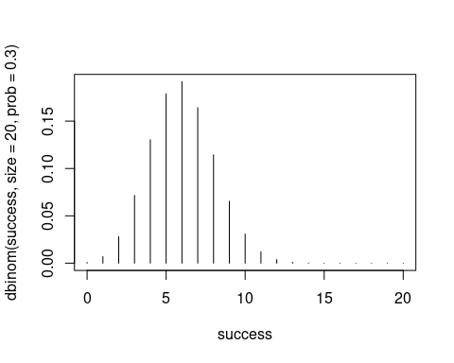

plot(success, dbinom(success, size = 20, prob = 0.3), type = 'b')

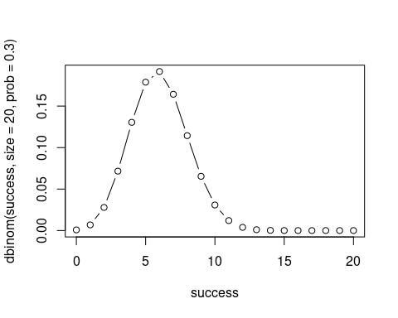

plot(success, dbinom(success, size = 20, prob = 0.3), type = 'p')

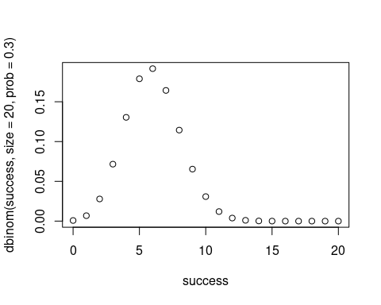

plot(success, dbinom(success, size = 20, prob = 0.3), type = 's')

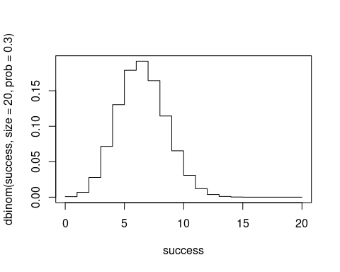

plot(success, dbinom(success, size = 20, prob = 0.3), type = 'l')

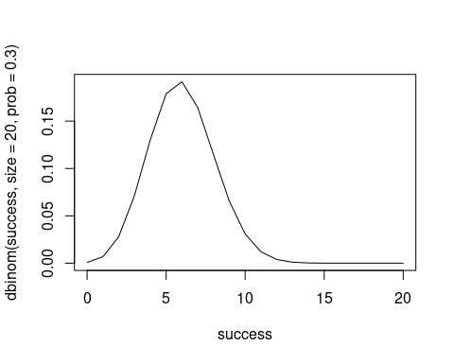

plot(success, dbinom(success, size = 20, prob = 0.3))



plot(success, dbinom(success, size = 20, prob = 0.3),   
type = 'h',  
main = "Binomial distribution (n = 20, p = 0.3)",  
ylab = 'Probability',  
xlab = 'Success',  
lwd = 3)

